A Robust Super Resolution Method for Images of 3D Scenes

Pablo L. Sala
Department of Computer Science
University of Toronto
Toronto, Ontario, Canada
psala@cs.toronto.edu

Abstract
From a set of images that overlap it is possible to obtain a new image that in the regions of overlapping has a higher resolution than that of each individual image. Such process is called Super-Resolution. In this work a method for robust super resolution is proposed and it is applied to obtain higher resolution images of a 3D scene from a set of calibrated low-resolution images under the assumption that the scene can be approximated by planes lying in 3D space.
Keywords
Super-resolution, robust-estimation, 3D scene reconstruction.

1. Introduction
Several super-resolutions methods have been proposed in the last two decades or so. However, so far, no work had been done for super-resolution of a set of images of a scene in 3D space. All the existing techniques assume only rigid transformations, or little mutual motion between images. In this work I present a robust super-resolution method and an algorithm that applies it for computing higher resolution images of a 3D scene.
For super-resolution to be possible it is necessary to perform an image registration step first. However, objects that are close to each other in an image of a 3D scene, may very well be far apart in another image of the same scene. Also occlusion can make disappear objects from one image to the other, even if both images are taken from relatively close viewpoints. All this makes registration a difficult problem when using images of 3D objects.
The algorithm presented here starts from a discreet set of planes in 3D space and for each plane performs super-resolution using for this task the back-projection of all images onto that plane. It is obvious that only the image pixels of 3D points of the scene that lie on the plane will be back-projected to the same points in the plane. For all other 3D points, the back-projection of its image pixels on the plane won’t coincide. In figure 1.1 an example of this fact is presented. Note that in the image plane of camera C1 the projection of region R will correspond to points in B, while in the image plane of C2 points of A will be projected as lying in R.
Therefore, when attempting to apply super-resolution to the images, it is important that the higher resolution image be obtained only for the pixels that project from same 3D points, and not to care for the pixels that don’t. This is achieved by means of the robust super-resolution method here presented. From the classical formulation of super-resolution as an optimization problem, an M-Estimation version of it using iteratively re-weighted least squares is derived.
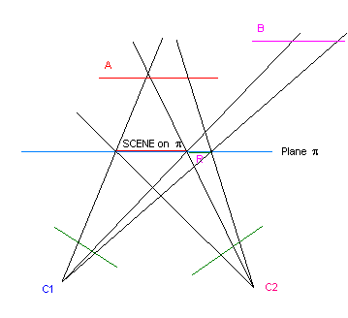
Figure 1.1. Example of the registration problem.

2. Historical Overview
A pioneering work in super-resolution was performed by Tsai and Huang [TSA84]. They used frequency domain methods, based on the theoretical basis laid by Papoulis [PAP77] with his Generalized Sampling Theorem. He had shown that a continuous band-limited signal can be reconstructed from samples of convolutions of the signal with filters of certain characteristics, and extended this idea to images (2D signals). Their work was generalized by Kim et al. [KIM90] to include noise and blur in the imaging process that had been disregarded by Tsai and Huang.
Gross [GRO86] method was to merge the low-resolution pictures over a finer grid using interpolation and then convolve the obtained picture with a restoration filter to de-blur it.
Later Irani and Peleg’s presented and approach taken from the Computer Aided Tomography field. Their algorithm resembles the back-projection reconstruction algorithm in which images are reconstructed from their projections in many directions. It starts with an initial guess and iteratively simulates the imaging process, retro-projecting the error back to the super resolution image. The methods of Tsai et al., Kim and Gross considered only translations. While Irani and Peleg’s technique allowed other types of rigid transformations between images, such as rotations and scaling.
Attempts to deal with noisy images were also presented. For example Schultz & Stevenson [SCH96] used Markov Random Fields to regularize super-resolution. They used a prior on the edges and smoothness of the image to compensate for bad motion estimation.
Finally, a high-speed algorithm applicable to video sequences was recently developed by Shekarforoush and Chellappa [SHE99]. They derived a closed-form analytical probabilistic method from a generalization of Papouli’s sampling theorem.

3. Problem Formulation
As stayed above, for super-resolution to be possible it is necessary an accurate knowledge of the relative scene locations sensed by each pixel of the observed images.
The presented method assumes that the scene can be thought of as mostly lying on planes in 3D space. Also it is required that all viewpoints be located in such a way that a plane can be placed between this region and the scene, to hold to a notion of scene depth.
From a set of N calibrated images of the scene taken from different viewpoints and a list of planes ordered by its depth, super-resolution will be attempted on each plane using the back-projection of all images on that plane. The images set is partitioned in disjoint subsets of relatively same size. The super-resolution will be applied to each subset, and the obtained higher resolution images will be compared. The regions of coincidence that have a significant size (or fulfill another criteria) will be assumed to correspond to parts of the scene lying on such plane. The portions of each image that correspond to these regions will not be taken into account when applying super-resolution in the following planes.

3.1. Standard Super-Resolution
Super-resolution can be formulated as an optimization problem: (see [ZOM01] for example)

$$E\left(\vec{X}\right)=\sum_{j=1}^{N}{{\left\|F^{j}\vec{X}−x^{j}\right\|}^{2}}$$
where X is the unknown higher resolution image,
x^{j} are the low resolution images, and
F^{j} = D^{j} H^{j} W^{j} are the imaging formation matrices, where D^{j} is a decimation matrix, H^{j} is a blurring matrix, and W^{j} is a geometric warp matrix.

Therefore, minimizing this objective function is equivalent to finding the higher resolution X that when “viewed” from the viewpoint of each low-resolution image, it differs the least from it.
Deriving E with respect to X and equaling it to 0 we get to:
$0=\frac{∂E}{∂X}\left(\vec{X}\right)=\left[\sum_{j=1}^{N}{{\left(F^{j}\right)}^{T}F^{j}}\right]\vec{X}−\left[\sum_{j=1}^{N}{{\left(F^{j}\right)}^{T}x^{j}}\right]$ (1)

And X can easily be found solving such sparse linear system.
However, some kind of robust estimation is desirable for the case in which the best obtainable higher resolution image X will not be able to decently approximate each low resolution pixel when projected back onto each image plane.

3.2. Robust Super-Resolution
I propose to apply M-Estimation to the previous formulation of the super-resolution problem. Let ρ_{σ} be Cauchy’s robust estimator:
$$ρ_{σ}\left(e\right)=\frac{e^{2}}{e^{2}+σ^{2}}$$
The robust version of the objective function is, therefore:

$$E\left(\vec{X}\right)=\sum_{j=1}^{N}{\sum_{i=1}^{M}{ρ_{σ}\left(e_{\text{ij}}\right)}}$$
where: $e_{\text{ij}}={\left(F^{j}\vec{X}−x^{j}\right)}_{i}$

Deriving E with respect to X_{l} we get:

$$0=\frac{∂E}{∂X_{l}}\left(\vec{X}\right)=\sum_{j=1}^{N}{\sum_{i=1}^{M}{\frac{∂ρ_{σ}}{∂X_{l}}}}=\sum_{j=1}^{N}{\sum_{i=1}^{M}{\frac{∂ρ_{σ}}{∂e_{\text{ij}}}⋅\frac{∂e_{\text{ij}}}{∂X_{l}}}}=$$

Using that $w_{i}^{j}=\frac{1}{e_{\text{ij}}}⋅\frac{∂ρ_{σ}}{∂e_{\text{ij}}}$ we arrive to:

$$=\sum_{j=1}^{N}{\sum_{i=1}^{M}{e_{\text{ij}}⋅w_{i}^{j}⋅\frac{∂e_{\text{ij}}}{∂X_{l}}}}=$$

It is easy to check that $\frac{∂e_{\text{ij}}}{∂X_{l}}=F_{\text{il}}^{j}$. So using this and replacing e_{ij} by its definition we get:
$$=\sum_{j=1}^{N}{\sum_{i=1}^{M}{{\left(F^{j}\vec{X}−x^{j}\right)}_{i}⋅w_{i}^{j}⋅h_{\text{il}}^{j}}}=$$
$$=\left[\sum_{j=1}^{N}{{\left(F^{j}\right)}^{T}W^{j}F^{j}}\right]\vec{X}−\left[\sum_{j=1}^{N}{{\left(F^{j}\right)}^{T}W^{j}x^{j}}\right]$$

where W^{j} is a diagonal matrix such that W^{j}_{ii} = w^{j}_{i}.
We have arrived to an iterative sparse system of equations of the shape:
$$A\left({\vec{X}}^{k}\right){\vec{X}}^{k+1}=b\left({\vec{X}}^{k}\right)$$
Notice that A and b both depend on the values of w^{j} and it is computed in base of the previous value of X. This technique is known as iteratively re-weighted least squares. For this method to converge, it is essential to start with a good initial guess X⁰. We’ll use the higher resolution image computed using the standard version of super-resolution (1) as our initial guess.

4. The Algorithm
Given a list L of planes in 3D space sorted from nearest to furthest; the images I^{j}, j=1, ..., N; and the camera matrices P^{j} corresponding to each image, do the following:
- Set O, the occluding 3D points set, to empty.
- Randomly partition the set {I¹,..., I^{N}} into two or more disjoint subsets S¹,..., S^{R}.
- For each plane π in L (chosen in order of depth, starting from the one closest to the front.) do:
  - For each subset S^{i} do:
    - For each image I^{j} in S^{i}, use P^{j} to compute the image formation matrix F^{j}. This matrix will emulate the imaging process on the j-th camera for the 3D points that are laying on plane π and that are not occluded by 3D points in O.
    - Obtain the super-resolution reconstruction X⁰ of the images in S^{i} on π, using for this purpose the recently computed image formation matrices.
    - Apply robust super-resolution, using X⁰ as the initial guess, and call the solution Y^{i}.
  - Blur each Y^{i} and compute the absolute difference images D^{kl} = | Y^{k} – Y^{l} |. Compute the regions of similarity by making T^{kl} = D^{kl} and then setting to zero all pixels which its value is below a threshold. Obtain the intersection of regions of coincidence as R = ∩ T^{kl}. Assume R to be the portion of the scene that lies on plane π. Update the set of occluding points O to include the points in R.
For this algorithm to be effective it is necessary that the list of planes cover all scene depth and that they be chosen to be more or less uniformly distributed and not too far apart one from the other. If some scene region R that lies in front, (from the viewpoint of some camera C^{j}), of other region V, is not found by the algorithm, then when trying to reconstruct for the plane where V (or part of it) lies, (occluded by R) the projection of R onto I^{j} will be used to approximate V, so misguiding the search. This is the reason behind the requirement that the scene has to be completely covered by the planes, and that they should be sorted from front to back.
Also it is important that the scene be highly textured for the similarity check to work well.

5. Experimental Results
A synthetic scene that consists of four images of 150 x 150 pixels placed in different vertical planes in 3D space was created to test my method. Twelve images were taken of the scene from random positions. The imaging process was simulated using a blurring, warping and decimation matrix, as explained above.
See figure 5.1 for a schematic of the scene layout. In table 5.1 the coordinates of the images in the scene are given.
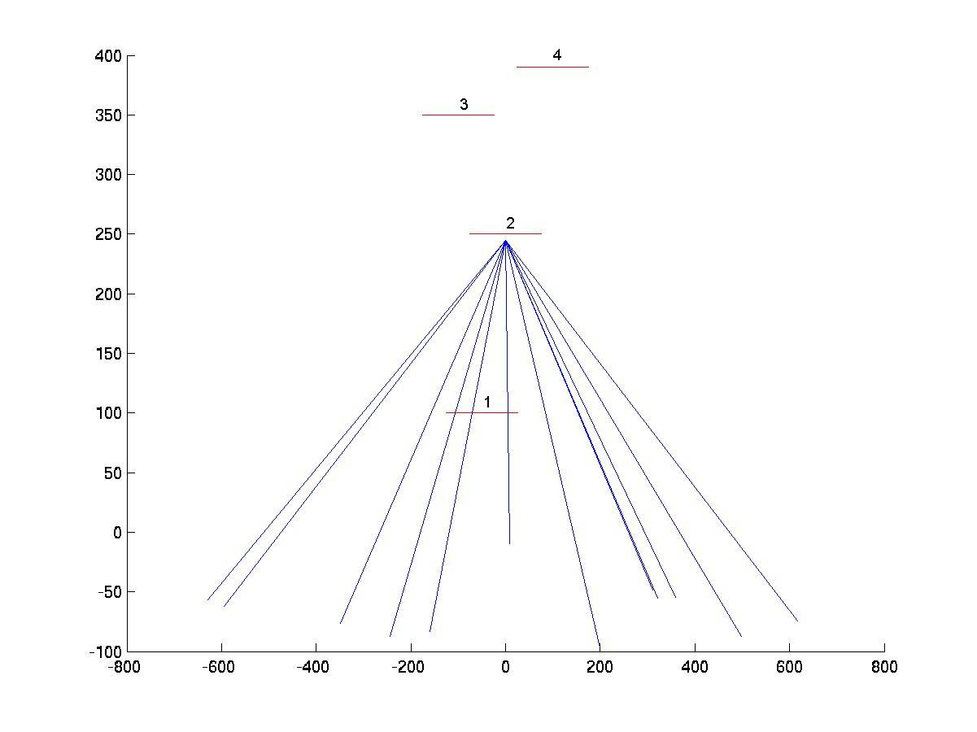
Figure 5.1. Scene layout. The scene images appear in red and the camera optical axes in blue.

The four images lying on the scene planes can be observed in figure 5.2
Table 1. Scene images coordinates
Image | Coordinates
1 | (-50,-50,100)
2 | (0,40,250)
3 | (-100,-30,350)
4 | (100,0,390)

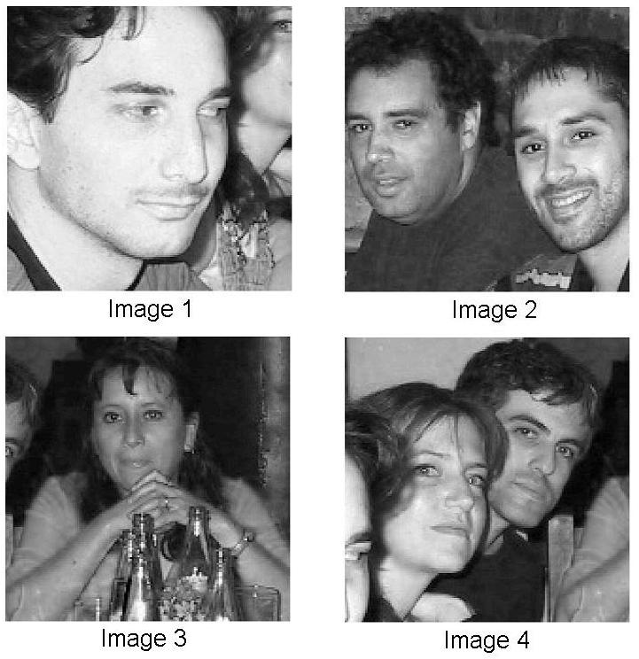
Figure 5.2. Scene images.

Zoomed portions of the twelve input images used in the experiments are shown in figure 5.3. The experiments were run randomly partitioning the set of images in two disjoint subsets. The first six images correspond to one of the subsets and the last six to the other.
An example of the images obtained when applying standard super-resolution vs. robust super-resolution can be seen in figure 5.4. Note that the image obtained using the standard method has much less contrast than the one obtained through the robust process. It is because each pixel projected from the plane is given the same weight for the purpose of finding the least square solution. The robust version doesn’t care in approximating the points in the plane whose projections differ with the pixels in the images; but focuses in approximating those points which their projections in the images have intensities close to that of the pixels to which they project.

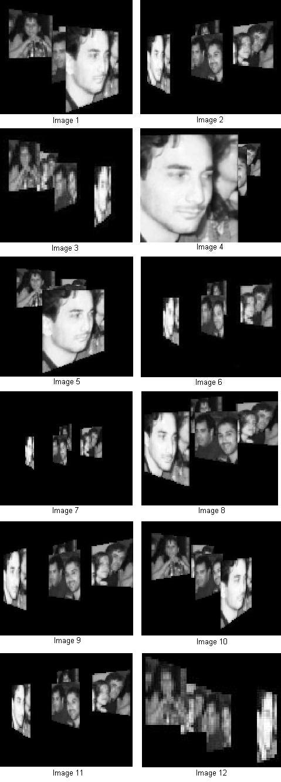
Figure 5.3. Input images.

A typical example when attempting to perform super-resolution in a plane where no element of the scene lies can be observed in figure 5.5. It can be seen that the reconstructions performed using both subsets of images don’t have much in common.

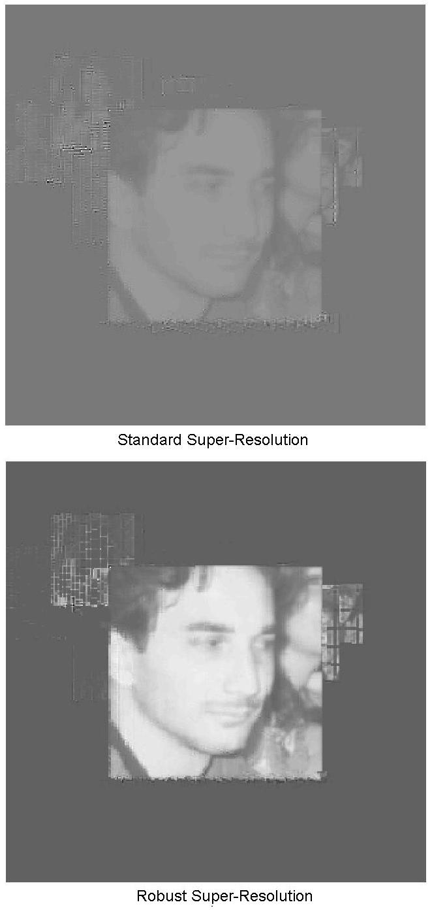
Figure 5.4. Standard vs. Robust super-resolution reconstructions.

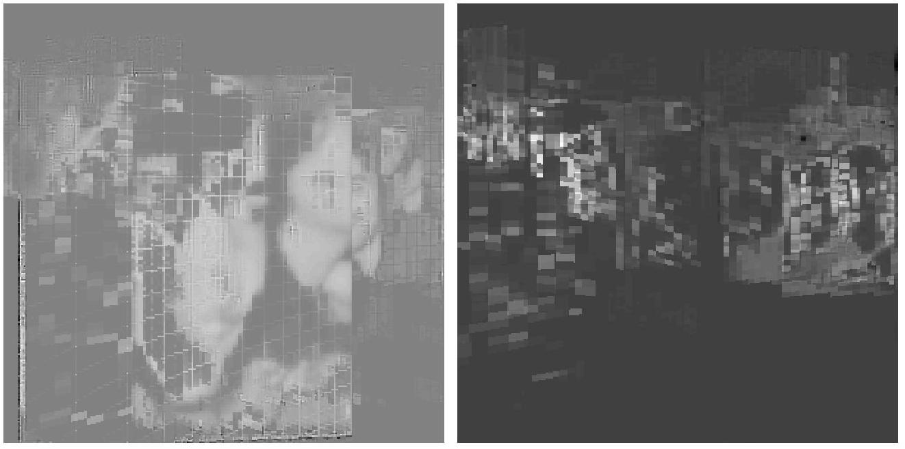
Figure 5.5. Reconstructions from the two subsets of images on a plane where no portion of the scene lies.

The higher resolution images obtained as output of the algorithm are shown in figure 5.6.
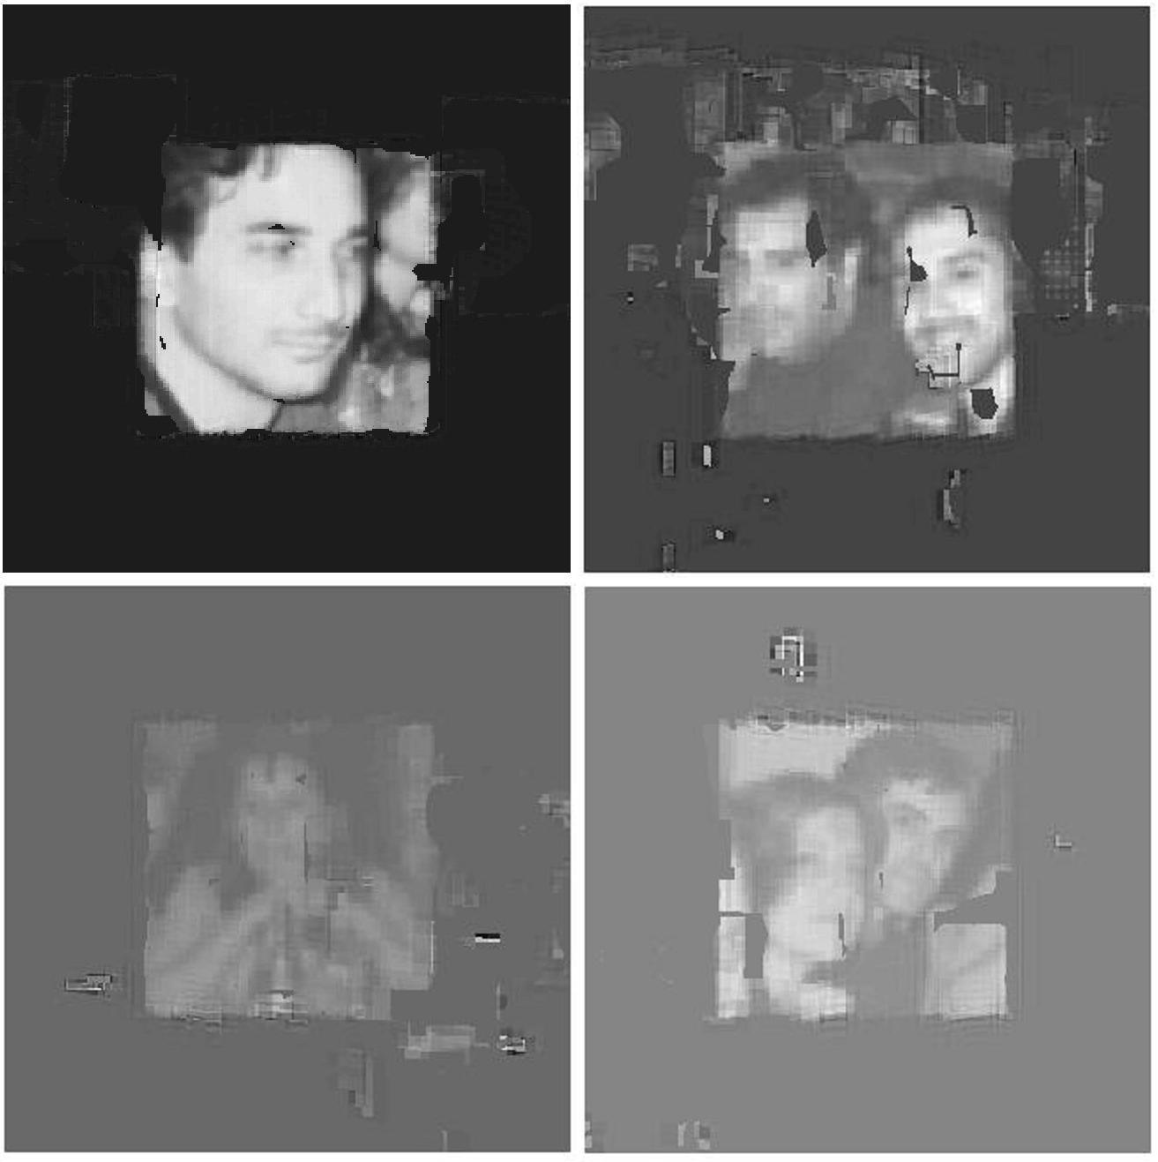
Figure 5.6. Higher resolution images obtained by the algorithm.

It can be seen that the results get worse as we advance in the 3D planes. The errors in defining precisely what portion of the scene lies in a plane irremediably affects the results of the super-resolution step in the following planes. Using more images and partitioning the images set in more than just two subsets will definitely give more accuracy to the similarity check.

6. Future Work
As seen in the experimental results, the precise detection of similarities between the super-resolution reconstructions is critical to obtain a good output. A possible extension to the proposed algorithm that might improve the results of the similarity check consists in using color images instead of just black & white images. In this manner more information for comparing the similarity of the reconstructions is available. The super-resolution steps of the algorithm should therefore be applied to each color channel separately and similarity would be assumed when the difference in reconstruction is close to zero for all three channels.

Acknowledgments
I’d like to thank Kyros Kutulakos for his fantastic Visual Modeling course, in which I’ve learned lots of useful tools and techniques for computer vision and graphics.

References
[KIM90] S.P. Kim, N. K. Bose, H.M. Valenzuela. “Recursive reconstruction of high-resolution image from noisy undersampled frames.” IEEE Trans. Acoust., ,Speech and Signal Processing., 38:1013-1027. 1990.
[PAP77] A. Papoulis. “Generalized sampling expansion.” IEEETrans. Circuits Systems, CAS-24:652-654. 1977
[SCH96] R. Schultz, R. Stevenson. “Extraction of high-resolution frames from video sequences.” IEEE Trans. Image Processing, 5(6):996-1011. 1996
[SHE99] H. Shekarforoush, R. Chellappa. “Data-driven multichannel superresolution with application to video sequences.” Journal of the Optical Society of Ametrica, 16(3): 481-492. 1999
[TSA84] T. S. Huang and R. Y. Tsai. “Multi-frame image restoration and registration.” Advances in Computer Vision and Image Processing (T. S. Huang, Ed.), Vol I, pp 317-339. JAI Press, Greenwich, CT. 1984.
[ZOM01] A. Zomet, S. Peleg. “Super-Resolution from multiple images having arbitrary mutual motion.” S. Chaudhuri (Editor), Super-Resolution Imaging, Kluwer Academic. 2001.

