From Non-Functional Requirements to Design through Patterns

Daniel Gross
Eric Yu
Faculty of Information Studies
University of Toronto
{gross | yu}@fis.utoronto.ca

- Introduction

The Requirements Engineering community has done a lot to establish RE as an activity of great importance on its own. Attention to requirements is crucial for quality. Equally important is how requirements drive the rest of software development, especially during the design phase. During the design phase, much of the quality aspects of a system are determined. Much of systems quality is expressed as non-functional requirements, also called quality attributes e.g. (Boehm, 1978; Bowen, 1985). These are requirements such as reliability, usability, maintainability, cost, development time, and are crucial for system success. Yet they are hard to deal with since they are hard to quantify, and often interact in competing, or synergistic ways. During design such quality requirements appear in design tradeoffs when designers need to decide upon particular structural or behavioral aspects of the system. A good designer is one who can do this well, and who has learned how to address a range of the quality requirements properly from experience.

The NFR framework (Chung, 1993; Chung et al., 2000) was one significant step in making the relationships between quality requirements and intended decisions explicit. The framework uses non-functional requirements to drive design (Chung et al., 1994) to support architectural design (Chung et al., 1995; Chung et. al, 1999), and to deal with change (Chung et al., 1995).

In the software design area, the concept of design patterns has been receiving considerable attention. Its basic idea is to offer a body of empirical design information (Coplien, 1996) that has proven itself and that can be used during new design efforts. In order to aid in communicating design information, design patterns focus on descriptions that communicate the reasons for design decisions, not just the results. It includes descriptions of the “why” not only of the “what” (Beck, Johnson, 1994). Given the attractiveness of the patterns approach, a natural question for RE is: How can requirements guide a patterns-based approach to design?

This paper argues that a systematic approach to organizing, analyzing, and refining non-functional requirements can provide much support for the structuring, understanding, and applying of design patterns. Using the NFR Framework for representing design patterns aids in better understanding the rationales of design, and making them more amendable to structuring and analysis. Design Patterns offer a convenient unit of design that is coarser grained than the ones manipulated by the NFR Frameworks approach.

We use an example from the design pattern literature to illustrate how the NFR framework can be used to represent and then guide the application of design patterns during the design process.

- Analyzing and Clarifying the Structure of a Design Pattern

Christopher Alexander, the renowned (building) architect widely acknowledged to be the originator of the pattern idea, explains that “each pattern is a three-part rule, which expresses a relation between a certain context, a problem, and a solution”. He adds that “as an element in the world, each pattern is a relationship between a certain context, a certain system of forces which occurs repeatedly in that context, and a certain spatial configuration which allows these forces to resolve themselves” (Alexander, 1979). Jim Coplien, a key player in the pattern community, adds that "if we understand the forces in a pattern, then we understand the problem (because we understand the trade-offs) and the solution (because we know how it balances the forces), and we can intuit much of the rationale. For this reason, forces are the focus of a pattern"(Coplien, 1996).

In this section we illustrate how the NFR Framework aids in analyzing and clarifying the forces that are involved in a pattern and how the solution resolves the forces. It is often remarked that pattern descriptions should be treated as literary form, the intent of our work is not to propose an alternative representation to replace the current informal pattern literary form. Each representation has its own merit and drawbacks. We rather see our proposed representation as an intermediate step that should aid in moving from an informal to a more structured description of the system. In particular we aim to clarify to the reader what the solution is and what tradeoffs the solution makes during the design process (Corfman, 1998, p.23).

As an example let us consider the Deviation pattern found in the "Points and Deviations Pattern Language of Fire Alarm Systems" by Molin and Ohlsson (Molin, 1998). The set of patterns described in their paper aid in designing the architecture for real-time alarm systems. The patterns address a variety of requirements and design issues relevant to that domain. These include, among others, requirements such as performance optimization and optimal utilization of limited memory, reliability (such as fault tolerance), maintainability, and portability.

Most patterns are written using predefined forms. Several pattern forms exist in the literature, each one differing from the other by the kind of categories they emphasize. Among others there exist the Alexandrian form (Alexander et. Al, 1977), the GOF (Gang of Four) form (Gamma et al., 1994), and the Coplien form (Coplien, 1995). See Coplien and Schmidt (1995) for more examples. All forms contain the basic categories: name, problem statement, context, description of forces, and solution. Sometimes pattern forms do not use all categories explicitly, but ask them to be discussed during the pattern presentation.

The form used in our example starts with its name and then with its general intent that says something about the solution. The intent section may also say something about important forces that are achieved in the solution (such as compact representation of the state of the system). The intent section is then followed by the context section which describes the current structure and behavior of the system in which the problem arises and the forces reside. Then the problem statement is given followed by the forces section. The forces section describes the tradeoffs and considerations of the designer. It may also include discussions of (obvious) solutions that a designer may think of but would not work within that particular context and set of forces. Then the solution is presented together with an explanation why the solution resolves the forces in a favorite manner. Finally, related patterns are discussed that the designer may find useful after having applied the solution.

Following is an abridged version of the pattern example taken from Molin and Ohlsson. We have added Italics to phrases, which we will discuss later in the paper.

Name
Deviation Pattern

(Intent)
The Deviation pattern provides a compact representation of the state of the system.

Context
The purpose of a fire alarm system is to survey a plant, a building or some smaller unit like an office or an apartment. The system makes use of a number of sensors distributed across the area being surveyed. Each sensor is connected to one of several control units. The control units, each of which is an autonomous computing node, are all connected to a common communication network and they normally operate as a single integrated system. … The key function of the system is to detect when something out of the ordinary occurs, such as fire or an indication thereof, and generate an alarm. When this happens, the fire alarm system takes appropriate action such as alerting people in the building, through alarm bells and text displays, invoking extinguisher systems, and calling the fire brigade automatically. … it also monitors itself continuously for abnormal internal conditions … for example, some communication channel is broken or a backup battery is failing … temporary disabled sensors or dirty sensors. When faults and disturbances are detected, they cause action to be taken in a manner similar to that of a fire alarm.

Problem
How do you implement the dependencies and information flow between alarm detection and actuators, user interfaces and other outputs?

Forces
The logical behavior of the system is completely independent of its distributed nature; an actuator may depend on some particular input regardless of whether it is connected to the same control unit or some other control unit in the system. Furthermore, the number of input to the system can be considerable, and the number of control units can also be large. If every control unit were to store the current status of every input sensor, it would place heavy demands on the memory capacity of each control unit. An alternative would be for each control unit to have only a proxy for remote inputs. Each proxy would consist of a system-wide reference, and any requests would be forwarded to the control unit where the input actually exists. However, storing as little as one reference per input in each control unit requires a great deal of memory space. …

Solution
Represent each detected deviation from the normal state as a Deviation object. Use Deviation subclasses, such as Alarm, Fault, and Disturbance to represent different kinds of deviations. Let deviation be the unit of distribution in the system in the sense that all deviations are replicated to all control units. Since the set of deviations defines the complete system state, this is immediately available on all nodes.

Related Patterns
Point defines entities responsible for creating and deleting Deviations, and Pool provides access to all Deviation instances.

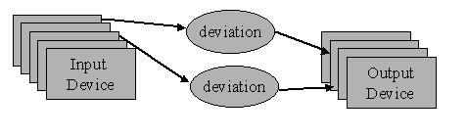
Figure 1: Deviation pattern resulting context (a logical view)

Figure 1 shows the Deviation pattern solution. It shows that deviation objects should be introduced which represent detected deviations by the input devices, these are replicated to all control units so that they would be “near” to each output device that might need them. Figure 1 is a logical view how output devices depend on input devices and does not show the control units.

The problem that the deviation pattern solves is basically the following: given a system of distributed control units processors, where input and output devices are attached to control units throughout the system. Given the need for output devices to depend on any input status in the distributed system. How should the input status of all input devices be distributed among the control unit memories such that the overall systems memory utilization is optimized while maintaining good performance (immediate access to any input status from output devices).

Deviation Pattern Discussed
Clearly non-functional requirements, such as minimizing memory utilization and good performance occupy a central place in the conceptual structure of the pattern. Yet, these requirements, their inter-relationships, and their impact on the resulting solution are hard to see and analyze given the textual representation only.

Figure 2 is a NFR goal graph that represents these relationships given in the pattern description. It shows that the designer has put up-front two major concerns during the design – minimizing memory utilization of the system, and achieving high performance. In pattern terminology these 2 top-level goals in the graph indicate that the basic question the designer faces is how to resolve the forces of minimizing memory utilization, while at the same time achieve high system performance.

Let us say a few words about the NFR Framework notation (please refer to the appendix for a legend of the notation used). The softgoal interdependency graph (goal graph for short) represents the non-functional requirements as softgoals (graphically shown as clouds to emphasis their fuzziness). Each softgoal has a type, such as “minimizing memory utilization”, and a topic, such as “system”. The type qualifies the topic. Together they express a goal that needs to be achieved during the design process (i.e. “minimizing memory utilization in the system”).

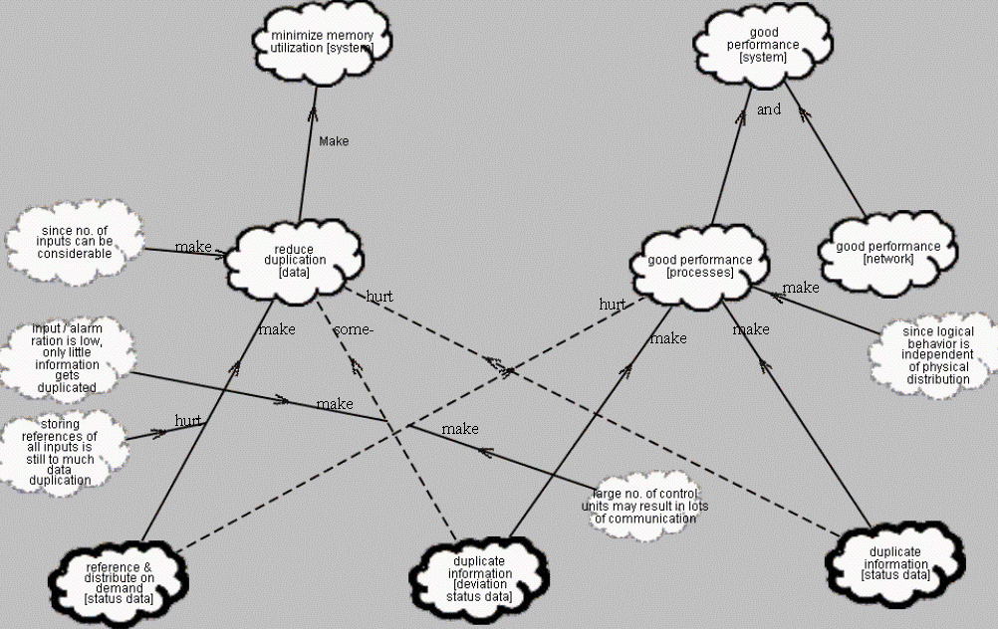
Figure 2: Deviation Pattern NFR Goal Graph
NFR softgoals (the light solid-line clouds) are refined through refinement links to sub-softgoals. Refinement describe how, and how well, sub-softgoals achieve their parent NFR softgoals. In our case achieving “reducing duplication of [data]” will “make” (i.e. sufficiently achieve) the goal of minimizing memory utilization. The direction of the arrow is the direction of the contribution. Other refinements exist in the notation such as "help" (positive contribution but not sufficient by itself to achieve the parent goal), “some+” which means there is some positive contribution of unknown extend towards the parent goal. The “and” refinement into two sub-softgoals means both sub-softgoals are needed to be achieved in order to achieve the parent goal (an "and" refinement implies "make" from each refinement link). "Break", "Hurt" or "Some-" denote negative contributions. These contribution types are used to help propagate the achievement status of the goals through the network inter-relationships using an interactive qualitative reasoning process as described in (Chung et al., 2000).

When NFR softgoals are refined to the extend that specific design techniques or options can be identified, these are expressed as "operationalizations" (soft) goals. They are shown as clouds with thick solid borders graphically). Softgoals may have additional impact on each other beyond those established through refinements. These "side effects" are called correlations and are shown as dotted line links. Arguments in support of (or to object to) goals or their contributions are “claims” softgoals and are shown as clouds with dotted line borders.

Taken together the elements of the NFR framework allow describing the design process, together with justifications and refutation of potential design decisions.

Returning to the example, the principle strategy that is suggested in the pattern to deal with memory utilization is reducing duplication of data within the system memory. The "make" link indicates that Reducing Duplication of Data would sufficiently meet the softgoal of minimizing memory utilization. Reducing Duplication of Data would be achieved by distributing input status by demand only (for example by using references to relate to remote input status data instead of physically distributing it all). Reference & Distribute on demand of status data is shown as an operationalized goal because the NFR's have now been reduced to an implementable technique.

However, the pattern argues that although using references to distributed data does in general reduce the memory utilization sufficiently (indicated by the "make" refinement link) this technique does not work well in our particular case, since storing references for all remote data is still considered to much data duplication. This argument is shown by the argumentation goal "storing references of all inputs is still too much data duplication" together with a "hurt" link pointing to the "make" refinement link.

The diagram also shows that using the Referencing and Distribute on Demand technique would introduce performance penalties by not give immediate access to status information. This is shown by a correlation link of type "hurt", originating from the operationalized goal "reference & distribute on demand [status data]" to the "good performance [processes]" softgoal, indicating that using such technique would "hurt" the performance goal of the processes in the system. This correlation link is not directly mentioned in the pattern text, but is implicitly derivable from it. The NFR modeling notation, by making NFR explicit goals, makes the designer look for such potential correlations in order to elaborate where alternative operationalizations goals, in fact, differ.

To address the performance goal for the system, the designers should address the performance of the processes within the systems control units, and the performance of the systems’ network. Note that the pattern description does not discuss optimizing the network explicitly, although the argument of having many control units might suggest a lot of communication needs during the replication of status information through the network. The goal graph structure leads us to making such implicit relationship explicit. We have not included that correlation link in the diagram in figure 2 to stay faithful to the description in the pattern text. In order to optimize the performance of processes that demand status information, one strategy could be to duplicate all status data within all control units. This, however, goes against the need for efficient utilization of memory, which wishes to reduce duplications.

Either of these two solutions attempts to optimize either memory only or performances only, and are therefore inadequate. The deviation pattern (the middle operationalized goal) overcomes these limitations. This third approach duplicates information in all control units but the information is about deviations from anormal states only. This solution sufficiently meets the goal of good performance for the processes (the "make" link). It has some negative impact on reducing duplications in the system ("some-" link). However, it is argued that in this particular application domain since the ratio of input sources vs. alarms generated is low, only little information needs to be replicated (argumentation supporting the previous correlation link). Having all deviation objects available at each control unit makes the data available to each output device and thus allows for its immediate access.

The diagram in figure 2 illustrates that pattern forces, as described in the pattern text (the Italics phrases) may often be regarded as non-functional requirements that exist within the problem domain that need to be identified, refined, and its tradeoffs analyzed during the design. When a designer applies this pattern, she is actually doing a lot of such NFR reasoning by balancing the forces, during her solution process. The value of the pattern is that the balancing was actually already done, and has a proven success record in existing systems.

The user of the pattern, however, still needs to understand the forces, and may need to tailor them to the specific situation (Coplien, 1998). This may involve elaborating on the pattern solution, and understanding how these affect the identified forces. The designer might identify other important NFRs (forces), and may wish to reason about their implications on the pattern solution. In particular when the designer might wish to follow and apply several patterns successively during her design. In such a case the designer might wish to understand how each of the pattern might impact the forces addressed so far during the design process.

Applying Patterns During Design

The previous section illustrated how one pattern can be understood more cleanly by analyzing the relationships among non-functional requirements and how they are addressed. This section considers the use of non-functional requirements during the application of design patterns when designing a system.

Figure 3 shows the kind of requirements the intended alarm system should meet. It includes the non-functional requirements mentioned in the previous section (by the clouds denoting softgoals on the left-hand side), together with a first elaboration of the functions the system should be capable of performing (task decompositions on the right-hand side). These include the ability to survey the physical environment by detecting out-of-ordinary occurrences, responding to those occurrences, and reporting facilities of the system status. Each one of these sub-functions is the refined into more particular functions, the system should be capable of performing.

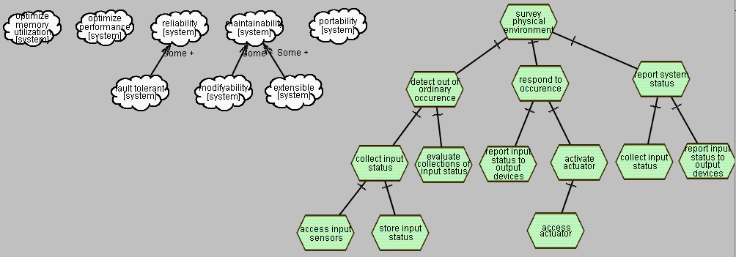
Figure 3: Functional and non-functional aspects of the alarm system
The question is, how can the system be further designed such that the non-functional requirements mentioned may be met, and how does that design relate to further refinements of the functional aspects of the system.

Molin's patterns discussed are the “Deviation”, “Point”, “Pool”, “Periodic Object”, “Lazy State” and “Data Pump”. Such a set of interrelated patterns within a particular domain is called a pattern language (Alexander et. al, 1979; Beck, 1994; Coplien, 1996). In this paper we will focus on two patterns only: the deviation pattern and the point pattern, and show how they address the non-functional requirements mentioned. In addition we wish to show in what way the NFR Framework representation of patterns aids in analyzing and reasoning about applying those patterns during design.

Applying the Deviation pattern
The deviation pattern described in the previous section comes to address the concerns of memory utilization and system performance. We will focus on the two strategies it proposes for replicating input status data throughout the system. One choice replicates all input status data to all control units, while the other choice only replicates deviant input status (only status information that deviates from a norm value). Each one of the choices addresses the non-functional requirements of memory utilization and system performance differently, and refines the current system functionality differently (i.e. code that replicates all data vs. code that replicates only deviant data).

Figure 4 shows how the deviation pattern is applied and what impact it has on the functionality. In order to avoid cluttering the diagram, figure 4 only shows a small part of the choices and reasoning shown in the Deviation pattern NFR goal graph in figure 2. One the left-hand side we can see the two strategies discussed in the deviation pattern for replicating data and how each one of them addresses the non-functional requirements differently. On the right side we can see how each one of the solution strategies generates an alternative refinement to the “input status replicated” functional goal.

Note that we have replaced the functional task “store input status” in figure 3 to an equivalent goal “input status replicated” in figure 4. Since through refining and analyzing how to achieve the non-functional part of the system, the designer arrived at the insight that storing status information may be done in a variety of ways. A goal is used to express the possibility of alternative choices, while a task represents a particular way of doing things. Relating the non-functional solutions to the alternative functional aspects of the system design (through the “make” links) allows us to show the rationales and justifications that went into their design.

The point we wish to make is that during the design of the functional aspects of the system, non-functional requirements also need to be achieved. Achieving the non-functional requirements along side the functional ones guides in generating and evaluating alternative functional designs. Figure 4 also shows that the designer has not yet addressed the other non-functional requirements.

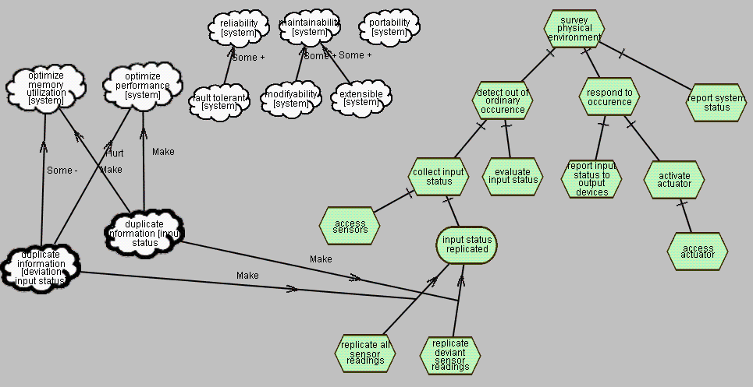
Figure 4: relating non-functional goals to functional behavior of the system

The Point Pattern
The designer now wishes to design the functionality for accessing the sensors, actuators and other output devices. She, however, recognizes that these devices all exhibit great variability in the type of sensors, their detection algorithms, access protocols, and physical packaging. An additional variation is the means by which sensors, actuators and other output devices are connected to the system. Some are connected directly to control units while others are connected through special devices. Sometimes these devices contain only one sensor while at other times a single device may contain a number of sensors or actuators -- each of which may be of different types. Despite the variations in the make-up of those devices, their logical behavior (such as requesting their status or activating actuators) are similar over all devices, sensors, actuators and output devices.

The point pattern problem statement therefore is: "How can the logical behavior of the system be separated from the variation among input sensors and output actuators?" In other words, how can a standardized interface be established which separates the logical behavior from the device variations.

Let us refer to the software that retrieves the input status information (such as the task “access sensors” and “activate actuators” in figure 4) as the "client code", and the software that services that request as the "service code". The client code requests status information through the service interface.

What is desired is to achieve standardization of the service interfaces. That service interface would then shield the client code from changes in the service provision implementations through that standard interface. Note that establishing a standard service interface contributes positively to the modifiability of the system. Since the service provision code can vary in its implementation and/or accommodate different types of service devices without affecting the client code.

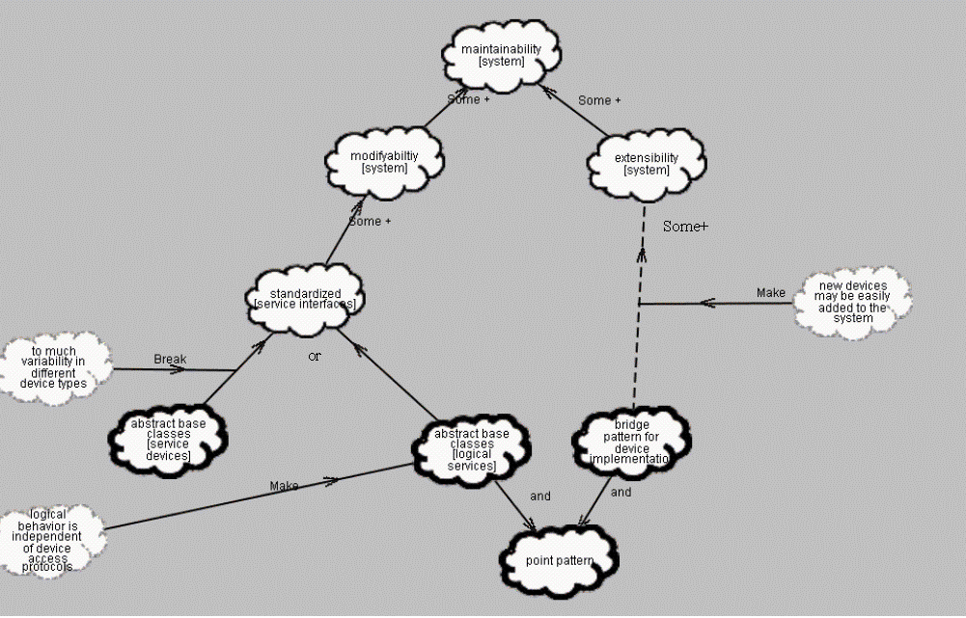
Figure 5: Point Pattern NFR Goal Graph
The point pattern describes two alternative strategies for achieving a standardized service interface. One approach is to create a standardized logical service interface for all devices that are attached to the systems control units. The interface would be defined as an abstract base class, and variations of device implementation would be defined in corresponding subclasses. This would be the most natural approach to establish the logical behavior within the base class and then have each sub-class implement its own way of relating to its device. It is, however, inadequate since in this particular problem context, the amount of input sensors or actuators that may be connected to one such device varies as well. This would introduce another element of variability that can not be accommodated in a stable manner within the device “abstract” base class interface.

The solution that the point pattern then proposes is to establishing a standard service interface for logical input and output relevant to the problem domain, such as for input sensors or logical output units. To this end the point pattern suggests defining an abstract base class called point. A device is then covered by a set of points. In addition the point pattern uses another pattern, the bridge pattern (Gamma et al., 1995) in order to decouple the point abstraction from the point implementation code. Figure 5 summarizes the forces and solution discussed in the point pattern above.

Note that Figure 5 shows that the point pattern is in fact addressing two distinct issues. It addresses the additional variability of devices by suggesting a logical rather than device oriented abstract service interface. The “abstract base classes [logical service]” softgoal shows this. It also addresses the issue of separating implementation code from interface code through the bridge pattern. This is a related but different concern, and is shown by the “bridge pattern for device implementation” operationalization softgoal. The bridge pattern therefore addresses extensibility issues, allowing for new devices to be added without affecting the point “client” code.

Note also that one drawback that using the bridge pattern implies is the performance penalty introduced by another layer of indirection (polymorphic invocation) between the clients interfacing and the implementation code. The use of the bridge pattern therefore has some negative effect on the performance of the system when accessing the sensor state information (or any other I/O devices). In order to stay faithful to the pattern description (it does not mention the performance penalty when using the bridge pattern) we have omitted it from the diagram in figure 5.

However, we include it in the next diagram (figure 6) to demonstrate how applying the point pattern may have impact on non-functional requirements (“forces”) already addressed by having applied previous patterns (“the deviation pattern”). This type of analysis is particularly important when dealing with non-functional requirements. As illustrated in the example, even though having made design choices for optimizing performance (by duplicating deviations), there is no guarantee that performance would not be adversely affected during subsequent design. Using the bridge pattern within the point pattern may still adversely affect the overall system performance. Thus when applying subsequent patterns, the designer needs to analyze whether and in what way already met non-functional requirements may still be negatively impacted.

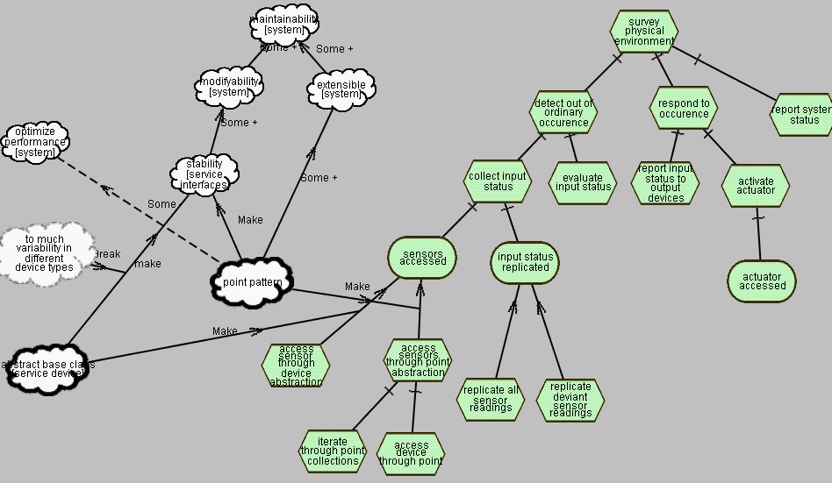
Figure 6: point pattern applied to the current design
Figure 6 summarizes the forces and approaches the point pattern discusses, the solution it offers, and how it relates to the functional requirements of the system. It omits the non-functional requirements not directly related to the design choices mentioned in the point pattern. It also summarizes the point pattern into one operationalized softgoal to simplify the diagram.

We can see that we now have two ways of having the sensors accessed. One is through a base class abstracting the notion of device, while the other is the point base class. Note again the switch from “accessing sensors” task to the “sensors accessed” goal symbol to indicate the availability of functional alternatives.

Figure 6 shows how each alternative approach for having the sensor accessed yields in different functional decompositions. The functional decomposition is guided according to the particular structure each approach in the pattern creates in the solution domain.

- Discussion and Conclusions

Although there has been some interaction between the pattern and the requirement engineering community, not much work has been done in using patterns to connect requirement to design, in general and the linking of NFRs and software patterns in particular. One interesting work that does picks up the idea of using patterns for addressing non-functional requirements in architectural design is in fact a later paper by Bosch and Molin (1999). In this paper the authors propose a software architecture design methods that is based on iterative evaluation and transformation cycles. First a rough high-level architecture is designed, which is then evaluated how well it meets the non-functional requirements of the system. Evaluation is done through a variety of techniques. Having identified problems in meeting non-functional requirements, transformation techniques, which are based on applying patterns, are used to optimize weak areas in the architecture to better fulfill the non-functional requirements, while making tradeoffs among others.

Although giving a very useful overall methodology of how to approach the design of software architectures, the method does not deal in detail with representing, analyzing the structural properties of patterns and the refining and analyzing of the evolving architecture, how they achieve or conflict with NFRs. We can, however, see how our approach could fit well into their general methodology and give more particular notation support and guidance where the authors have left the analysis and reasoning to the intuition of the designers only.

In general, we can see a great deal of synergy in linking the two areas of research. Both research areas wish to deal with improving the design process and may benefit from incorporating concepts from each other. Following are some of the benefits for the pattern work that may arise when incorporating the concepts of NFRs:

- Clarifying the role of NFRs in design patterns.

NFRs are really pervasive in the discussions about patterns, though they are not singled out as such and not really analyzed. For example, reusability, modifiability, transparency, performance, etc. are common issues in patterns. They appear most prominently in "forces", but may also appear in other parts of pattern descriptions, such as the problem, context, intent, motivation, rationale, etc. Recognizing that patterns in fact deal with NFRs would allow taking advantage of research done in the RE community to aid in specifying and analyzing NFRs.

- Providing structure for characterizing each pattern

NFRs are clearly crucial for understanding each pattern. Though the pattern community insists on keeping pattern description informal, the level of structuring that the NFR framework provides for understanding the relationships among competing and complementary forces can be very helpful. Additional structuring that may be useful is the NFR framework basic distinction between "NFR type" (the quality attribute, e.g., reusability) and "topic" (what the quality attribute qualifies, e.g., a coordination object). Semantic structures from conceptual modeling techniques are also useful.

- Providing a better understanding and analysis of the relationship among patterns

If each pattern has clearer structure as described above, then the relationships among patterns would also become more perspicuous. For example, they may be related via their positive or negative forces, via the problem structure, etc.

- Providing a richer way for developing and expressing pattern languages.

This follows from the above point. Current pattern languages are typically directed acyclic graphs with a single type of link with no clear semantics. Such graphs can be enriched by other kinds of semantic relations, showing how a number of patterns together can lead to the design of whole systems.

- Better retrieval of patterns

With more explicit structure, patterns can be retrieved more easily from a richer catalogue. There can be more dimensions for indexing, accessing and navigating the catalogues.

- systematic support for the application of patterns during design

The goal graph approach in the NFR framework offers a systematic way for applying generic knowledge to address design goals. Patterns for addressing goals can be retrieved, selected, then applied to the situation. The designer could tailor the pattern to the situation by making tradeoffs among the identified forces. The resulting context and remaining forces would then lead to the next design step, in which the designer could search for the next set of applicable patterns, understand their forces and interactions, then select among alternatives. These are well supported within the NFR framework.

Introducing Patterns to the NFR work should also be very interesting. The NFR framework takes a very fine-grained approach to design. Goals are decomposed and refined along types and topics. Then they are "operationalized" into concrete design elements. Each of these elements are rather minute and must be combined to form the solution to the entire problem (e.g., the design of an entire system or subsystem). Patterns, on the other hand, are rather coarse-grained, aggregate solutions. They are packages of design elements that are already known to work well together, from experience (the forces are already well balanced)

The two approaches, therefore, can be very complementary. The patterns approach needs a way to link to requirements, while the NFR approach needs a way to aggregate its fine-grained solutions The NFR approach is goal-driven, whereas the pattern approach is solution-driven. One is top-down and the other is bottom-up. The two should be combined because the most interesting design decisions are probably happening in the middle.

Appendix

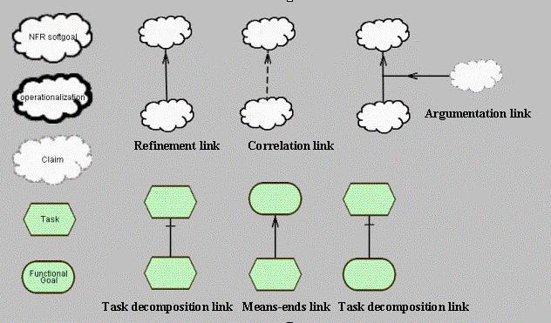
Figure 7: Modeling notation legend

References

Alexander, C. (1979). The timeless way of building. New York,: Oxford University Press.

Alexander, C., Ishikawa, S. j. a., & Silverstein, M. j. a. (1977). A pattern language : towns, buildings, construction [by] Christopher Alexander, Sara Ishikawa, Murray Silverstein, with Max Jacobson, Ingrid Fiksdahl-King, Shlomo Angel. New York,: Oxford University Press.

Beck, K., & Johnson, R. (1994). Patterns Generate Architectures, Proceedings of the 8th European Conference on Object-Oriented Programming (pp. 139-149). Bologna, Italy.

Boehm, B. W. (1978). Characteristics of software quality. Amsterdam New York: North-Holland Pub. Co.;
American Elsevier.

Bosch, J., & Molin, P. (1999). Software Architecture Design: Evaluation and Transformation. IEEE Engineering of Computer Based Systems Symposium.

Bowen, T. P., Wigle, G. B., & Tsai, J. T. (1985). Specification of Software Quality Attributes (Report RADC-TR-85-37). Griffiss Air Force Base, NY: Rome Air Development Center.

Chung, K. L. (1993). Representing and using non-functional requirements : a process-oriented approach. Toronto, Ont.: Department of Computer Science University of Toronto.

Chung, L., Gross, D., & Yu, E. (1999). Architectural Design to Meet Stakeholder Requirements. In P. Donohue (Ed.), Software Architecture (pp. 545-564). San Antonio, Texas, USA: Kluwer Academic Publishers.

Chung, L., Nixon, B., & Yu, E. (1994). Using Quality Requirements to Systematically Develop Quality Software, Proceedings of the 4th International Conference on Software Quality . McLean, VA, U.S.A.

Chung, L., Nixon, B., A., & Yu, E. (1995). Using Non-Functional Requirements to Systematically Select Among Alternatives in Architectural Design, Proceedings of the First International Workshop on Architecture for Software Systems . Seattle, Washington.

Chung, L., Nixon, B., & Yu, E. (1995). Using Non-Functional Requirements to Systematically Support Change, Proceedings of the 1st International Symposium on Requirements Engineering (RE'95) (pp. 132-139). York, England.

Chung, L., Nixon, B., A., Yu, E., & Mylopoulos, J. (2000). Non-functional requirements in software engineering. Boston: Kluwer Academic.

Coplien, J. O., & Schmidt, D. C. (1995). Pattern languages of program design. Reading, Mass.: Addison-Wesley.

Coplien, O., James. (1995). A generative development process pattern language. In O. Coplien, James; Schmidt, D., C. (Ed.), Patttern languages of program design . Readings, MA.: Addison-Wesley.

Coplien, O., James. (1996). Software Patterns: SIGS Books & Multimeida.

Coplien, O., James. (1998). Software Design Patterns: Commom Questions and Answers. In L. Rising (Ed.), The Pattern Handbook: Techniques, Strategies, and Applications (pp. 311-319). NY: Cambridge University Press.

Corfman, R. (1998). An Overview of Patterns. In L. Rising (Ed.), The Patterns Handbook: Techniques, Strategies, and Applications (pp. 19-29). Cambridge: Cambridge University Press.

Gamma, E., Helm, R., Johnson, R., & Vlissides, J. (1995). Design patterns : elements of reusable object-oriented software. Reading, Mass.: Addison-Wesley.

Martin, R. C., Riehle, D., & Buschmann, F. (1998). Pattern languages of program design 3. Reading, Mass.: Addison-Wesley.

Molin, P., & Ohlsson, L. (1998). The Points and Deviation Pattern Language of Fire Alarm Systems. In R. R. Martin, Dirk; Buschmann, Frank (Ed.), Pattern Languages for Program Design 3 (pp. 431-445). Readings MA: Corporate & Professional Publishing Group.

We have put the intent section in brackets since the authors have not named it explicitly.

