To Rama,

Happy birthday, my dear Rama,
Always be grateful to your mama,
For giving birth to such sweet girl,
Smart, funny, pretty as a pearl.

I wish you best in this new year,
Perhaps you’ll marry Richard Gere.
But at the least I wish you joy,
Eat healthy food, consume some soy.

I wish your research turns out great,
For many veggies on your plate,
For following your happy fate,
For sometime meeting a nice mate,
For never being way too late,
Etc… , Etc…

Let all your problems disappear,
May you always know no fear,
I pray you always find that spike (in the brain),
And hope you buy yourself a bike.

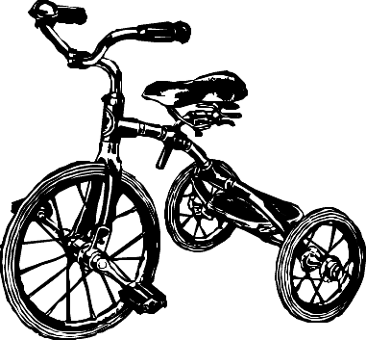

From Alex

