A rough HotCRP & ACM guide for new conference Publication Chairs
I recently served as the publication chair for PPoPP 2019, and was asked shortly thereafter if I could share some instructions / hints on how to do this in future. I wasn't terribly organized as I went about my duties, but here's a quick attempt at piecing some instructions together. Feel free to ask me whatever you can think of, and I'll try my best to answer. As far as I can remember, my duties were something like:
1. Configure HotCRP to allow authors to submit final versions (see below).
2. Email authors asking them to submit final versions (system did not do this for me automatically, although it looked like it might when I was doing #1).
3. Choose a tentative order for all papers in the proceedings (also asking the chair for input) [final order to be decided later]
4. Submit the table of contents to ACM via the submit TOC to ACM button (it can also be resubmitted later) [see notes below, where I include screenshots]
5. Design the front matter for the conference, by compiling a PDF with a cover page (and cover image --- find one that is creative commons), the sponsor logos, chair's welcome message, the artifact evaluation committee message, the credits (acknowledgments, including external reviewers --- finding everyone's affiliations was a challenge...), and obviously the table of contents.
6. Track authors' submissions and email authors that have errors with their submissions (over and over).
7. Ensure that authors submit ACM rights management forms (with exactly matching authors, author order and paper titles). You can have the system send an e-mail blast with links to ACM rights management forms, but if there are late additions (like BAs), you won't want to send more and more e-mail blasts, so you will have to copy links to rights management forms and manually e-mail authors on late additions.
8. Authors that accept brief announcements late in the process will need to be added / have their status changed to accepted as BA (or something similar), and will need manual e-mails describing what they have to do (acm rights management form and submission instructions). (Expect to add lots of extra submissions after the fact, and to keep updating the paper order and TOC.)
9. They organizers may ask you to include abstracts for tutorials or keynote speakers. These must be added manually, and acm rights management forms must be signed. However, the rights can be less restrictive (acm just gets "permission to use," and no real copyright is relinquished).
10. Decide whether to allow extra pages, and if so, you have to coordinate the extra pages. In our iteration, we simple gave +1 extra page in the final version (compared to submission), and +2 extra pages to be used however you like (except it should include at least a paragraph or two about your artifact) if you passed artifact evaluation, and disallowed extra pages beyond that. The ACM has nothing to do with this decision, and there are no fees or charges beyond what you as a conference decide.
11. Many authors will ask for help figuring out how to resolve errors in their submissions. Unfortunately, I sent probably one hundred e-mails along these lines... You may be more or less helpful than me. :) By the way, you have some freedom in whether you as a publication chair will accept some minor errors (like “page 2% too long,” etc.). The system will inform you that there are some errors, but will allow them to slide. Other errors (like PDF font types) are more serious.
I've pasted some of the e-mail templates I came up with, below.
If your experience is like mine, throughout the entire process, I sent about 1,000 e-mails via mass e-mail blasts, and about 150 manual emails.
==========================================
Dear authors,

The final camera ready copy of your submission is due on *January 4th*
(11:59pm AoE), and must be uploaded using HotCRP before the deadline.
Detailed instructions appear below.

Title: xyz
Authors: abc
Paper site: https://conf2092.hotcrp.com/paper/.............

Submissions should use the up to date ACMART (La)TeX class or Word
template, which can be downloaded directly from the ACM
(https://www.acm.org/publications/proceedings-template). For (La)TeX users,
the download includes several example (La)TeX files. The relevant example
file for this submission is "sample-sigplan.tex". Note that the appropriate
document class command for this submission is
"\documentclass[sigplan]{acmart}".

If your submission was accepted as a full paper, then your final version
can contain up to 11 pages of content, including tables and figures, but
excluding references. (I.e., references do not count towards your page
limit.) If a code artifact was submitted for artifact evaluation, then you
are granted two additional pages to include your artifact instructions (for
a total of 13 pages plus references).

If your submission was accepted as a poster, then you should submit a two
page short paper. Note that the two page limit includes everything (even
references). The title of your paper must begin with the *exact text*
"POSTER: " in both the PDF *AND* in all conference meta-data (visible on
HotCRP). For example, if you paper was submitted under the title "Awesome
Parallel Widgets", your new title will be "POSTER: Awesome Parallel
Widgets".

Alongside the camera-ready PDF, you will be required to *submit the source
files* for your paper, including ALL files which were used to create the
final output (PDF), be they Word, LaTeX, image files, etc. This is
mandatory.

Submissions must include appropriate ACM Computing Classification
categories and terms. Details on the ACM Computing Classification System
can be found here (https://www.acm.org/publications/class-2012), and a flat
view of all categories and terms can be found here
(https://dl.acm.org/ccs/ccs_flat.cfm). Paper keywords (specified with the
\keywords command in (La)TeX) are optional, but appreciated.

For each submission, the ACM *must* receive a completed rights management
form. You have already been sent a request to complete and submit one. If
you do not see this e-mail, please check your SPAM folders. If this form is
not received for a paper before the deadline, then that paper *cannot* be
included in the proceedings. After completing the rights management form,
you will be sent the correct rights text and bibliographic strip to place
within your paper. This rights/bibliographic text must be entered into the
paper *before* the final PDF is generated and submitted.

Additional details:
- Submissions must not include page numbers, and need not include the "ACM
Reference" that is included in the sample (La)TeX file. Use
"\settopmatter{printacmref=false, printfolios=false}" to remove these.
- All PDFs must use Type 1 fonts, and fonts *must* be embedded in the PDF.
Instructions for checking fonts in a PDF using Adobe Reader can be found
here (https://www.ics.uci.edu/~chenli/pdf-font-types/index.html).
- If you use (La)TeX, then your submitted archive should compile to PDF
without errors or warnings upon executing pdflatex; bibtex; pdflatex;
pdflatex.

Contact John Doe <john.doe@university_or_lab.tld> with any further questions
or concerns.

Best regards,
John Doe
Publication Chair

==========================================

Dear xyz,

I am writing to you because either:
(1) you have submitted a rights management form and your title did *not*
start with "POSTER: ", or
(2) you have not submitted a rights management form.

You must submit a correct rights management form by *Jan 4th* or your
abstract will not be included in the proceedings.

Your current HotCRP title is:
"abc"

You may still edit this title, but you must tell me if you do so (as I must
resubmit documentation to the ACM). Regardless of what you choose as your
final HotCRP title, it *must* begin with "POSTER: " and you *must* edit the
ACM rights management form title to match.

Please submit your new ACM rights management form using the (same) link
that was sent to you earlier.

- John Doe, Publication Chair for PPoPP 2019

==========================================

Dear xyz,

Your submission suffers from one or more of the following errors. Please be
sure to correct any such errors before the deadline.

Missing references
Missing source files
Missing ACM Computing Classification
Missing ACM keywords
Bad font
Missing font

Best regards,
- John Doe, Publication Chair for PPoPP 2019

==========================================

Dear xyz,

This is a friendly reminder that the final camera copy of your submission
is still needed, and the deadline is approaching (approximately two hours
from now). Please upload your PDF and source files as soon as possible.

Additionally, if you have not yet completed an ACM rights management form,
please complete and submit one (using the link sent to you earlier), or we
will be unable to include your submission in the proceedings.

Best regards,
- John Doe, Publication Chair for PPoPP 2019

==========================================

Dear xyz,

Just a friendly reminder (since I am unsure if the ACM SIGCMS system has
notified you today) that your ACM rights management form is still missing,
and must be filled out today.

If your paper was accepted as a poster, its title in the ACM SIGCMS system
must start with "POSTER: ".

The title and authors list of your paper in the ACM SIGCMS system must
match the title and authors list in HotCRP.

Best regards,
- John Doe, Publication Chair for PPoPP 2019

==========================================

Dear Author(s),

Please complete and submit the ACM rights review form for your submission, which can be found here:

http://cms.acm.org/forms/prform.cfm?confID=...&proceedingID=...&paperID=...&sequence=1

If this form is not completed, the submission cannot be included in the proceedings.

Best regards,
John Doe
Publication Chair

==========================================

Dear Tutorial Author,

In order to publish your tutorial abstract, we will need you to assign
ACM the "right to use" your abstract. I believe this can be done at the
following link.

http://cms.acm.org/forms/prform.cfm?confID=...&proceedingID=...&paperID=...&sequence=1

Best regards,
Trevor
Publications Chair for Conf’2092

==========================================
Quick questions:
1. Does the publication chair decide on the due date for final camera ready version? Is it in consultation with anyone (ACM or program chair)?
In my case, I was simply given a date by the general chair. ACM does impose some restrictions (final publication package must be ready absolutely no later than 3 weeks before conference start), but the final deadline should usually fall quite a bit before ACM's cutoff to be safe.
2. In general, how is ACM's involvement throughout the process?
You have mentioned that ACM doesn't care about things like page limit. What about other things like rights management form? Do they prepare the form for us or do we have to create the form (manually entering correct title, author, etc.)?
Largely hands-off. :) Anything that goes wrong in hotcrp is something ACM doesn't know anything about, so you have to talk to hotcrp people instead. I only had one thing go wrong in hotcrp (a bug!), and I don't think it'll happen to you. The ACM might also finalize the proceedings at some point without your input, at which point you'll be unable to make changes. If this happens, just e-mail them and they can reverse this. Time wise, I'd say 99% of everything falls on you.
They prepare the forms when you submit the TOC. (Whenever you add a paper, you need to submit the TOC again, which will generate a new form, but you'll have to send the form link to the authors manually.) Usually title and authors list should be fine. However lots of authors change title and even author list after the submission, as I've found...
==========================================
Here are some screenshots of the places I spent the most time in HotCRP. They might be helpful.
The following is the "ACM" submenu of the "Settings" menu. This is where I spent most of my time. On the side menu, see the "Decisions" tab also. That's where you set up the system to take final CR copy submissions.
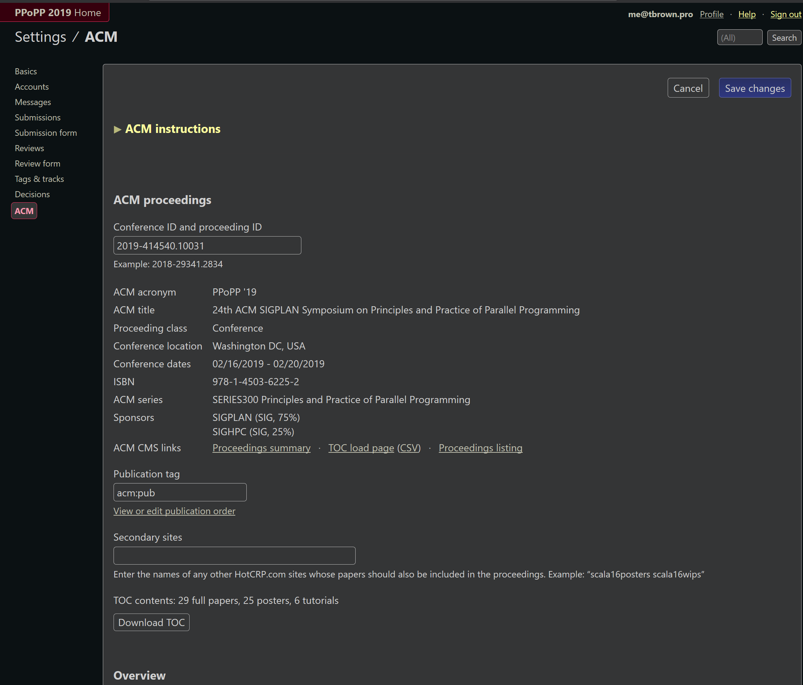
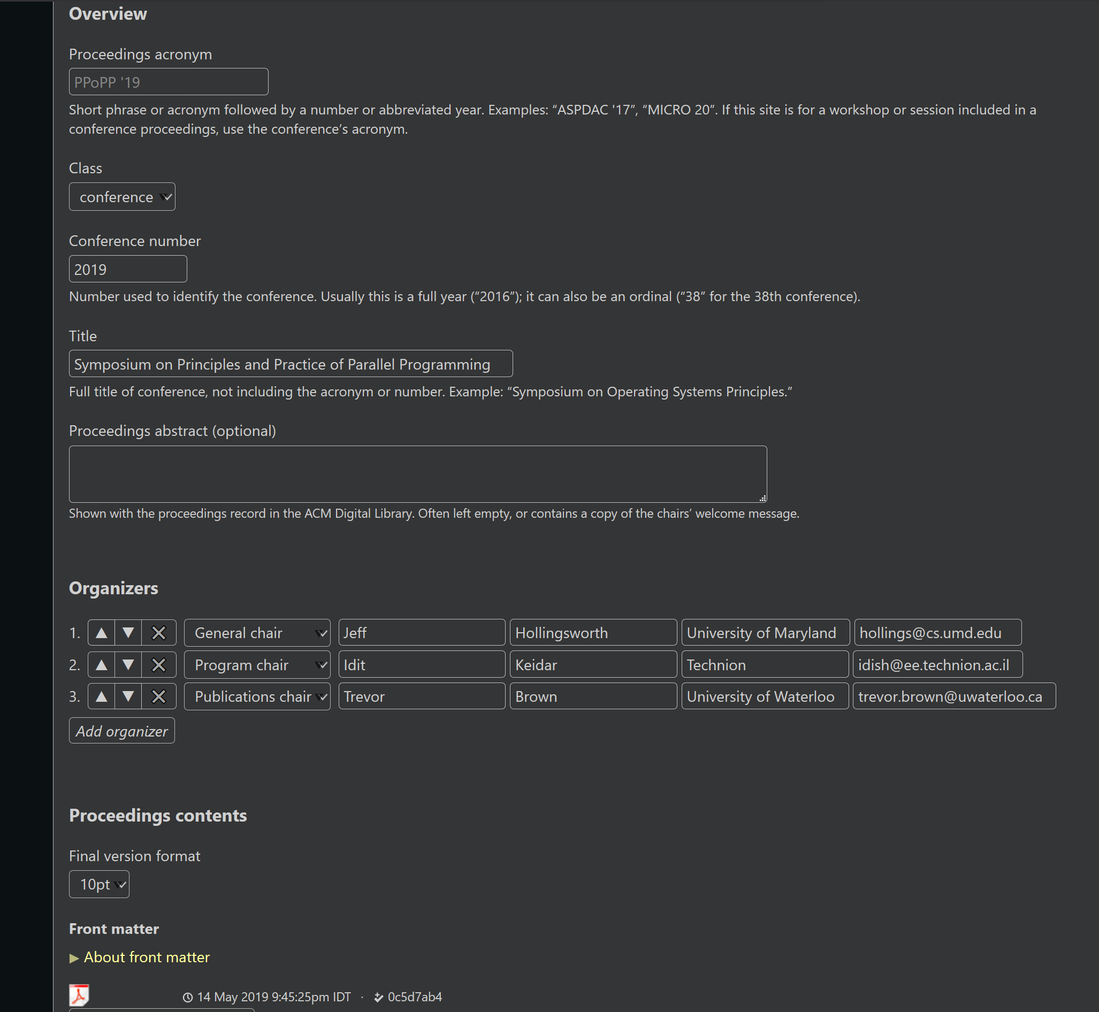
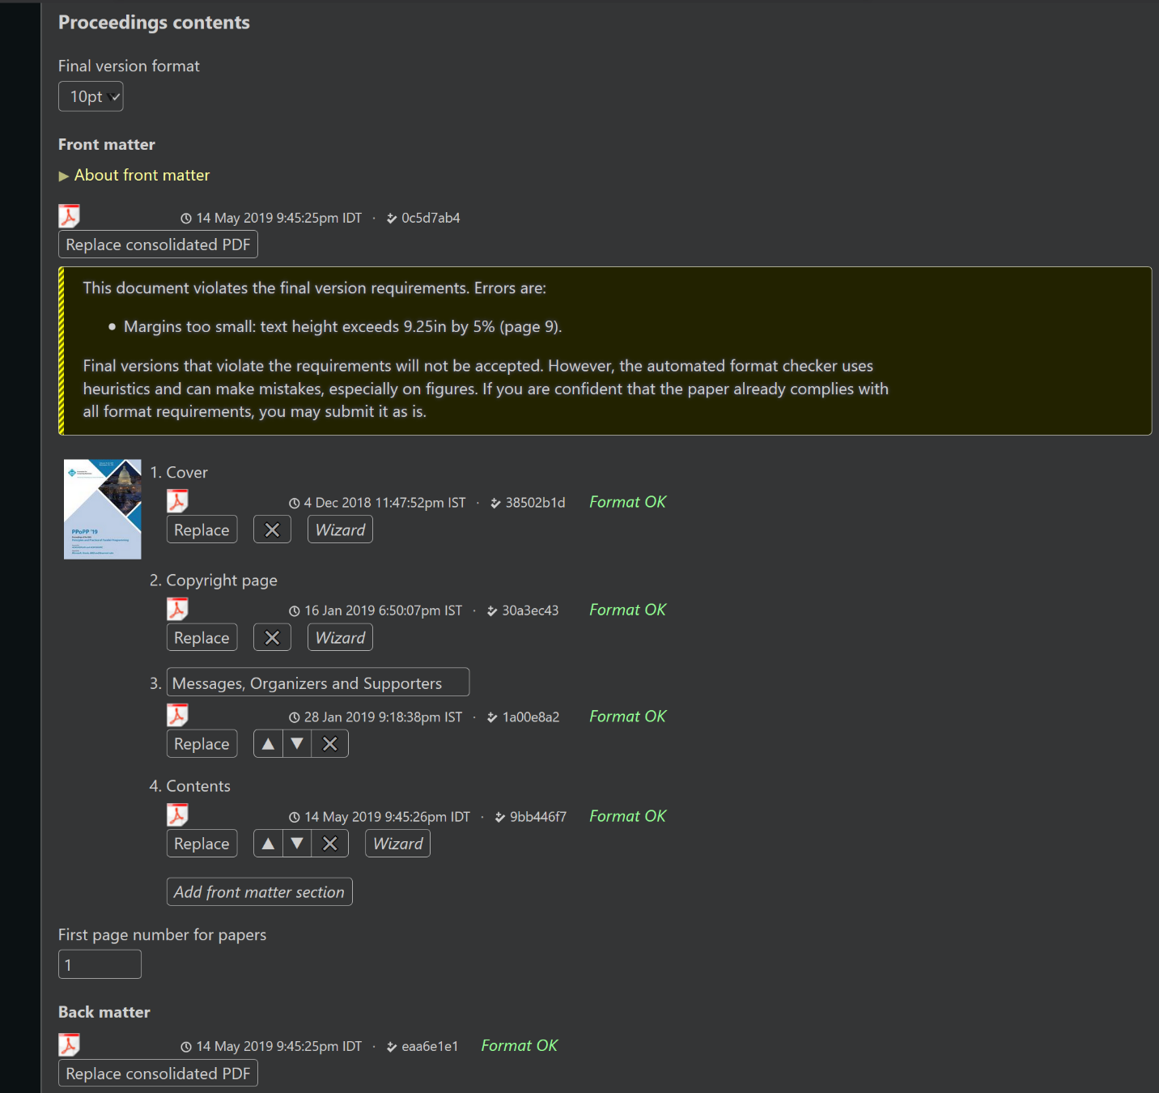
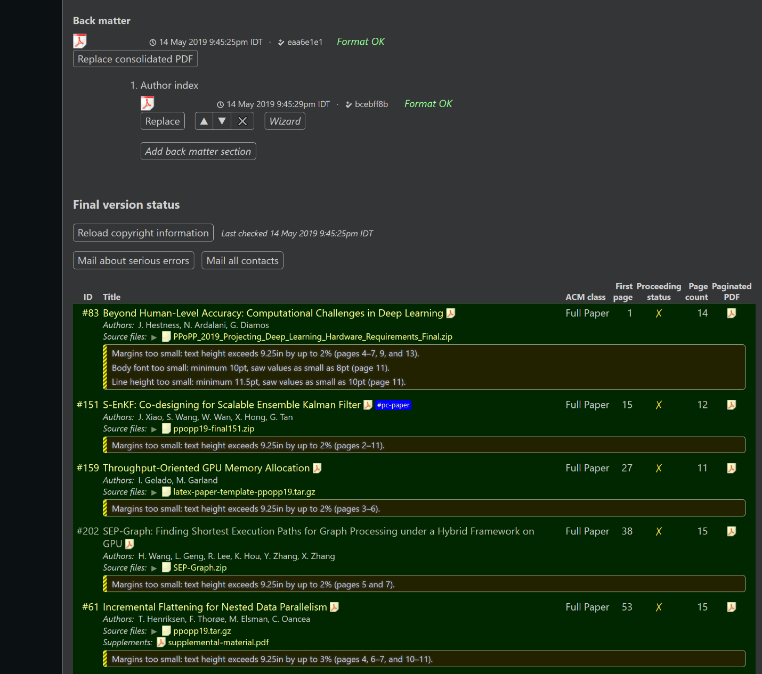
[…]
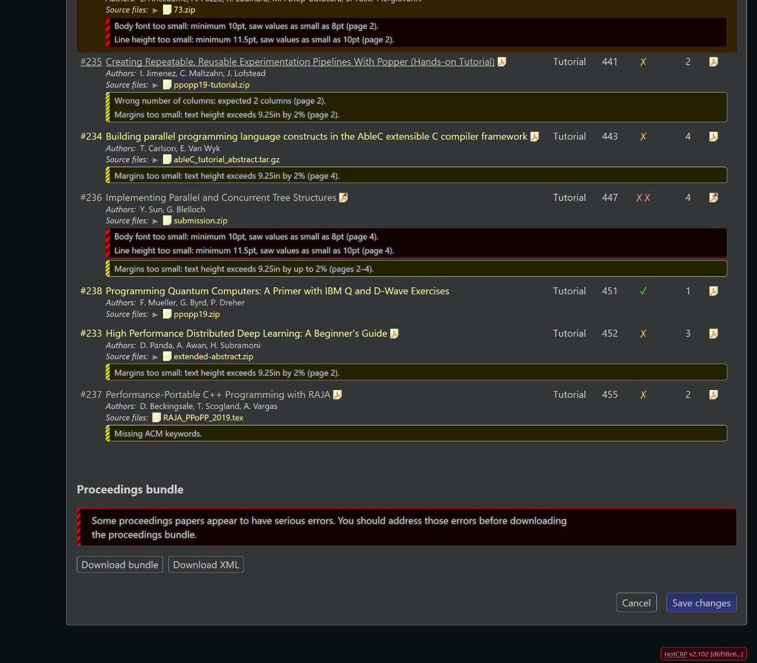
In these "ACM menu" screenshots, the links "view or edit publication order" "Download TOC" and "Proceedings listing" are most useful.
“View or edit publication order” must be done once all accepted papers have been decided, and after each paper that is added late. It must be done before “Download TOC.”
“Download TOC” can be done repeatedly, but the first time you do it (and only the first time), the ACM SIGCMS system will send e-mails to all authors of currently accepted papers, inviting them to submit a rights management form.
"Proceedings listing" takes you to the ACM SIGCMS system which is where you monitor rights management forms, and get links to send to authors of late submissions to have them fill out the forms manually.
Here is the ACM SIGCMS system:
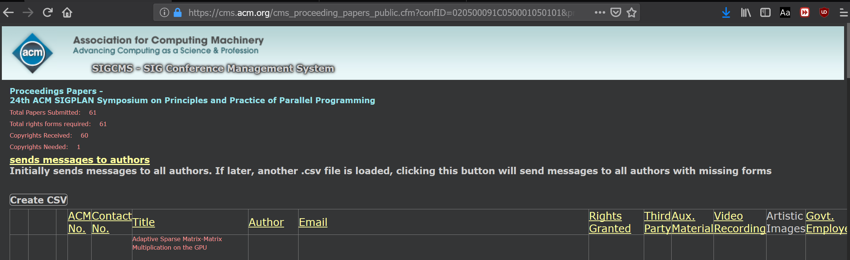
The following is a screenshot of the “Decisions” tab in the “Settings / ACM” menu. This is where you set up the system to accept final camera-ready versions of accepted submissions.
